**2.1. PostgreSQL Installation**

Run the program “*installer_PostGreSQL.exe”. The following screen is shown:*

Click “Install” to install PostgreSql. 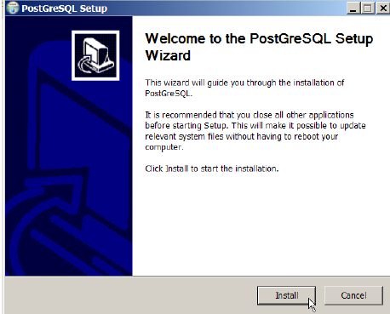

1) Click “Next”

2) Click “Next”

3) Keep the selections as they are and click “Next”

4) Insert “postgres” as the password for the postgres user of the system

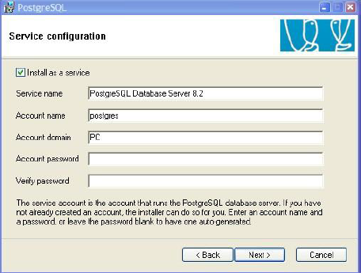

5) Click “Yes/Ok”. If it asks to create an account.

6) Click “No” is you get this message

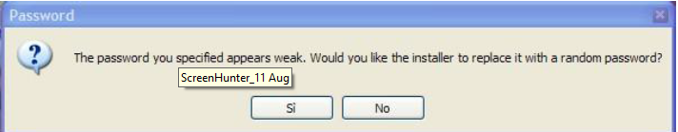

7) Insert “postgres” as the password for the postgres user related to DB and click “Next”

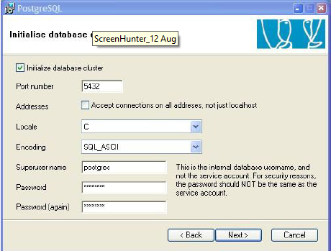

8) Click “Next” through the rest of the prompts. Click Finish

**2.2. XAM Installation**

Run the program *OrangeLink-windows_W.X.Y.Z_installer.exe*. The following screen is shown:

1) Click “Yes/Ok”

1) Click “Install”

17 XAM – Xatlas As Middleware – User Guide

2) Click “Next”

3) Click “Next”

18 XAM – Xatlas As Middleware – User Guide

4) Click “Next”

5) Click “Next”

19 XAM – Xatlas As Middleware – User Guide

6) Click “Next”. The installation of the program begins.

7) Wait until the installation is finished.

20 XAM – Xatlas As Middleware – User Guide

8) At the end of the installation click “Finish”.

If you are installing an update of the program, e.g. you already have a DB containing the configuration of your plant, click “No”.

Otherwise, if you want to start again from the scratch, press “Yes”: please be careful, because pressing “Yes” will cause the creation of a DB with all the default settings.

Finally, you will be asked if you want to start XAM services immediately:

9) Click “Yes”

21 XAM – Xatlas As Middleware – User Guide

Now you are ready to launch XAM by means of the “Start” menu or by means of the icon that you will find on the desktop.